Networks in their surrounding contexts

Summary by Lu Zhang and Jin Miao

1. Homophily: the principle that we tend to like our friends

Social links form:

* Intrinsic
* Social environments

Measuring homophily:

Suppose with no homophily, friendships are formed as though there were random mixing across given characteristics. If there is homophily, we should see if the cross-charateristic edge is significantly less than random mixing.

For example: red – girls; white - boys

https://mail.google.com/mail/u/3/images/cleardot.gif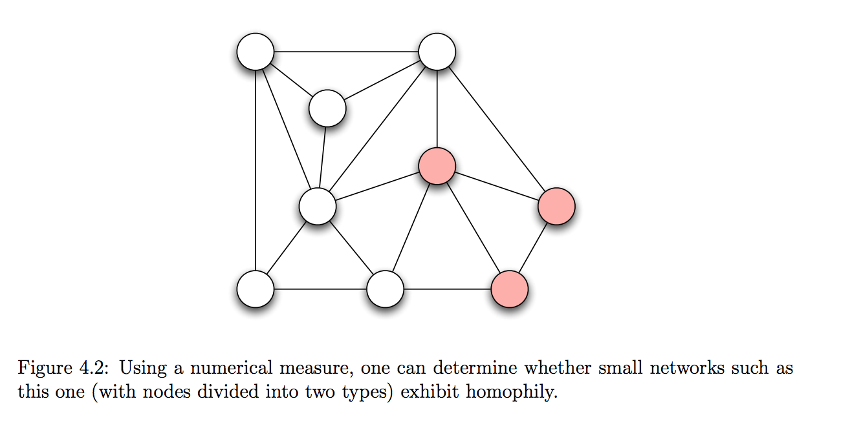

5 out of the 18 edges above are cross-gender. P(boys) = 6/9 = 2/3; P(girls) = 3/9 = 1/3

If there is no homophily, the cross-gender link should be 2*1/3*2/3 = 4/9 = 8/18. But we see 5 cross-gender links rather than 8.

1. Mechanisms underlying homophily: selection and social influence

It could be homophily formed because of

* selection (more immutable) (you choose to be friends with those similar to you in some characteristics) or
* social influence (immutable and mutable) people may modify their behaviors so that they are more similar to their friends.
* Longitudinal studies can help to understand the interplay between the two mechanisms

(like chicken-egg question)

* Implications: e.g. interventions. If social network formed more by social influence, through influencing the behavior of targeted person, the whole network’s behaviors could be modified (e.g drug use, obesity)

1. Affiliation

Contextual factors (organizations, companies, hobby, etc.) also become a node in the network. Contextual factors named foci – focal points.

For example,

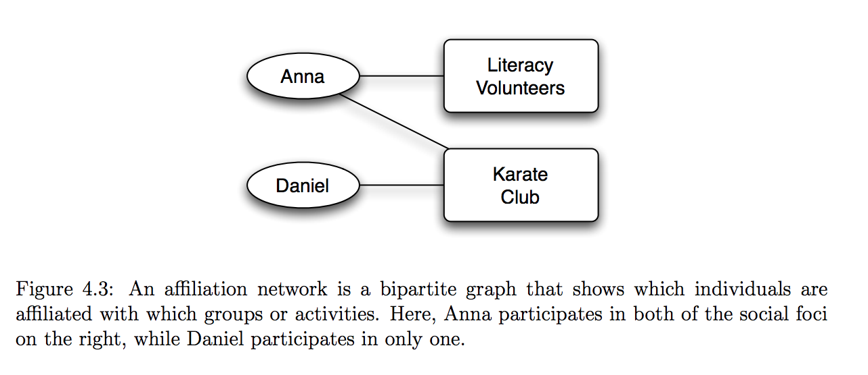

bipartite graph: (2 sets) all edges go between the 2 sets

* Implications: understand patterns in structured activities

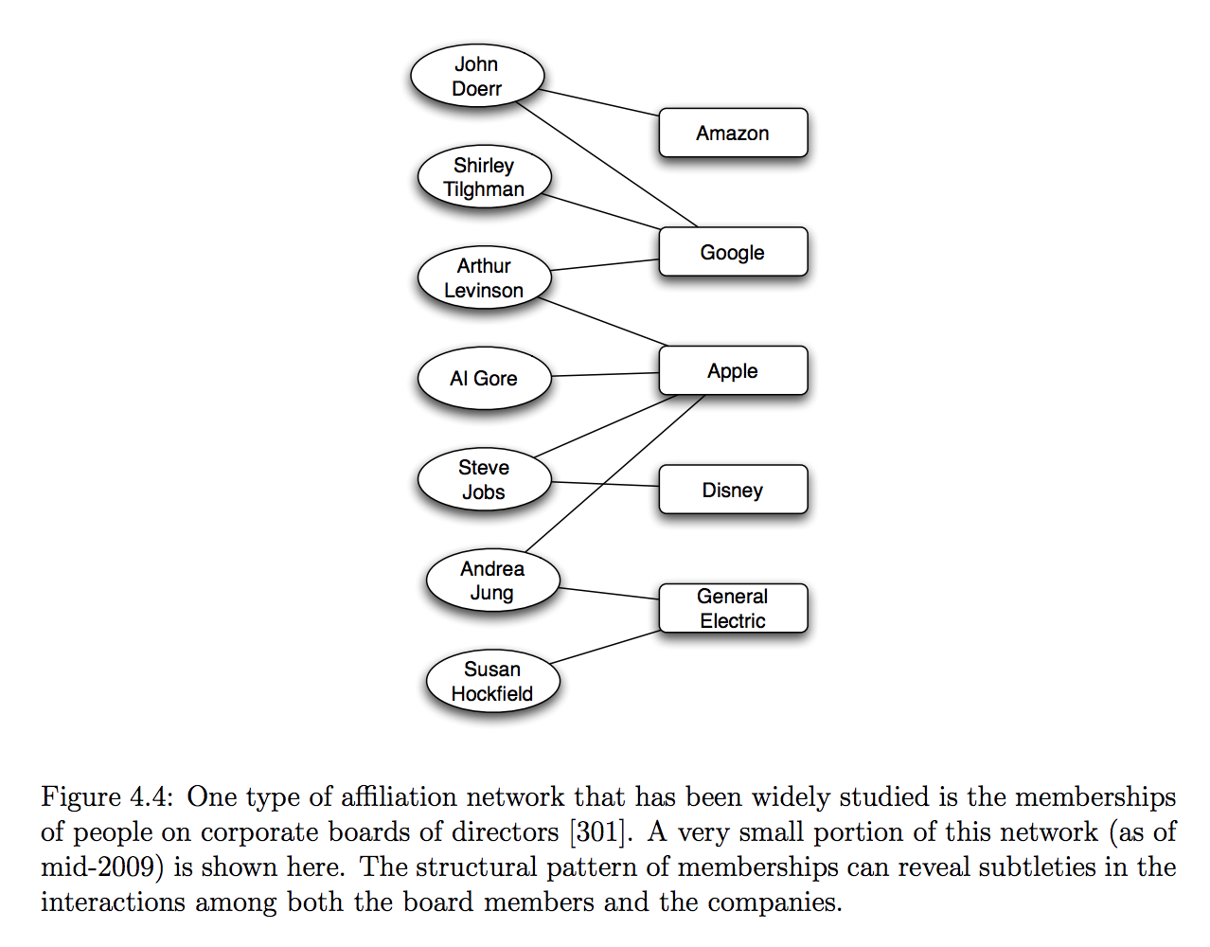

* Coevolution of social and affiliation networks
  + Both social networks and affiliation networks change over time -> coevolution may influence the other
  + Social-affiliation network representation

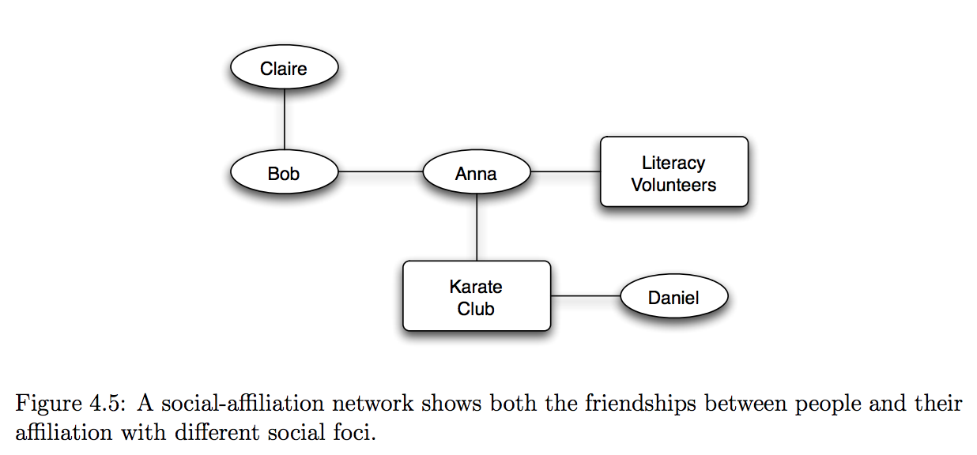

* + This can help us understand the role of different mechanisms play in forming links:

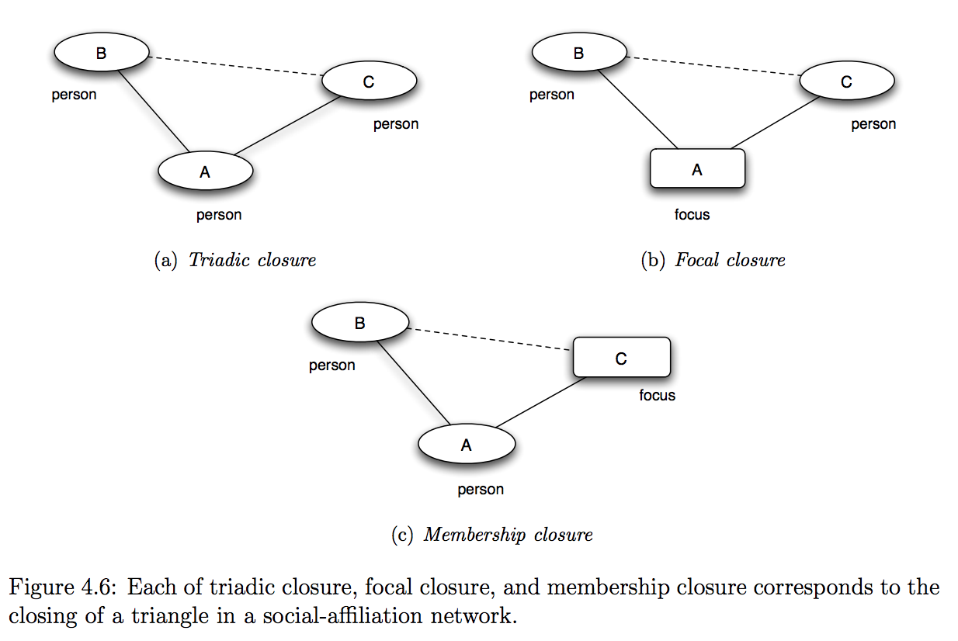

a). B introduces A to C

b). Activity A introduces both B and C

c). A introduces B to activity C

1. Tracking link formation in online data

Question: how much more likely is an edge to form if they have multiple friends in common as compared to 1 friend, 2 friends?

Methods:

* 2 snapshots of network at different times
* for each k, identify all pairs of nodes who have exactly k friends in common at first time period but have not formed a link yet
* 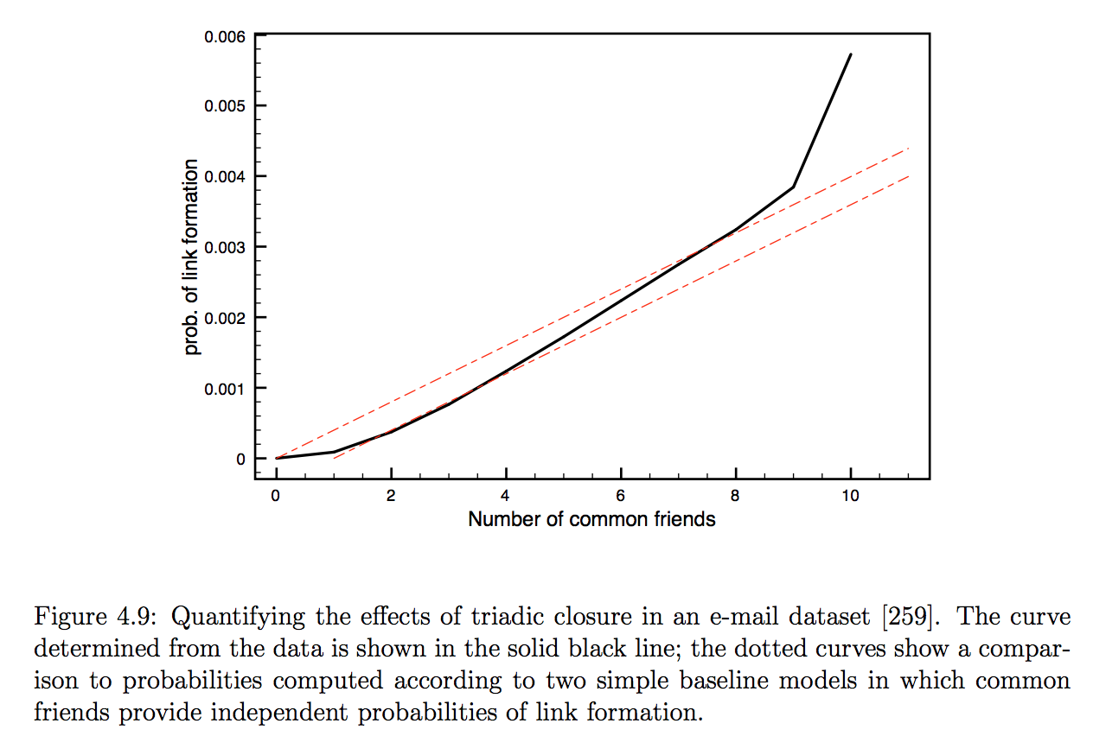T(k):= fraction of pairs formed an edge by the time of the second snapshot
* comparison with baseline models:
  + T_b(k) = 1 – (1-p)^k each common friend that two people have in common give them an independent probability p of forming an link each day (dotted line – linear fashion)
  + Plots suggest the independent assumption about the common friends may not hold

1. Schelling’s Model

* Objective
  + to demonstrate how global patterns of spatial segregation can arise from the effect of homophily operating at a local level
* Model assumptions
  + Population of individuals called agents
  + Each agent of type X or type O
  + The two types represent some characteristic as basis for homophily (race, ethnicity, country of origin, or native language)
  + Agents reside in cells of a grid (simple model of a 2‐D city map)
  + Some cells contain agents while others are unpopulated
  + Cell’s neighbors: cells that touch it (including diagonal contact)
* Local mechanism 
  + Each agent wants to have at least some t other agents of its own type as neighbors (t the same for all)
  + Unsatisfied agents have fewer than t neighbors of the same type as itself and move to a new cell
* Dynamics of Movements
  + Unsatisfied agents move in rounds
  + Results are robust with respects to variations in movement issues
* Results and Interpretation
  + http://nifty.stanford.edu/2014/mccown-schelling-model-segregation/
  + Spatial segregation is taking place even though no individual agent is explicitly seeking it
    - T = 3 implies that agents just want to avoid being too extreme minority in their own area
    - Theoretically, complete integration is achievable.
  + From a random start, it is very hard for the collection of agent to find such integrated patterns. More typically, agents form larger clusters
  + Local preferences of individual agents have produced a global pattern that none of them necessarily intended.
* General comments
  + Immutable characteristics are highly correlated with mutable characteristics. As homophily draws people together along with fixed characteristics, it creates a natural tendency for mutual characteristics to change in accordance with the network structure.
  + Shelling intentionally simplified the mechanism to show that local interactions leading to segregation are remarkably robust.